ILLiad Connection Manager Troubleshooting

OCLC Customer Services Division

Abstract

Basic functionality, dependencies and general troubleshooting of the ILLiad Connection Manager.

Date

6/30/2020

ILLiad Connection Manager:

Basic Functionality, Dependencies, and General Troubleshooting

# How do I know if there’s a problem?

* Main Menu Alerts (Stop Sign)

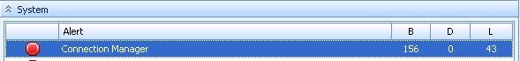

* Log entries indicating errors
* OCLC Requests Not downloading/Updating
* Complaints from Other Sites (about your site’s OCLC updates, etc.)
  + Note: These are usually related to very specific issues, like for example the Article/Loan OCLC RequestType issue, where Loans are sometimes mistakenly updated as Articles and vice versa under certain specific conditions.
    - The specifics of this issue are still being investigated. As yet, we’re still unsure of the specific set of variables that cause the problem, but multiple variables appear to be involved.

# Dependencies:

## The ILLiad Connection Manager Service:

* ILLiad Connection Manager service
  + The installed ILLiad Connection Manager Windows service is running the .exe located in:

**X:\illiad\Connection Manager\ConnectionManager.exe**

where “X” is the drive letter upon which the “illiad” folder (sometimes referred to as the ILLiad Share) is installed.

* + If in doubt, you can determine the exact location of the .exe being referenced by the service by going into Server Management under services, locating the ILLiad Connection Manager Service, right-clicking on it, and selecting properties.
    - The “Path to Executable” value displays on the “General” tab directly above the “Startup Type” dropdown.

## Relevant Ports:

* **Port 443**: Port opened only outbound from the ILLiad web server to OCLC's server (**webservices.oclc.org**). This allows the ILLiad Connection Manager and ILLiad Client to contact OCLC for update and download purposes.
* **Port 1433**: (for hosted servers, the default alternate SQL port is 1344, but self-hosted systems can use just about any other open port for SQL connectivity, if modified to do so): Port opened only outbound from the ILLiad web server to the SQL Database server. This allows the Connection Manager to communicate with and update the ILLiad database on the SQL server.
  + Note: If this port is blocked from the ILLiad server, you have bigger issues than the Connection Manager, as nothing will be able to talk to the database from the ILLiad server, including the ILLiad Client.

# Standard Logging:

* The Connection Manager service logs directly to the “Log” table in the ILLiad database.
  + Note: There is no physical log file created on the ILLiad server for this service.
* The Connection Manager log is accessible from the ILLiad Client:
  + Double Click the alert line, go to the “Log” tab
  + Log displays within the client interface.
  + If desired, you can adjust the “Show Entries After” date value on the Client ribbon to allow for different dates, although you should be aware that only a certain number of entries, usually a few days’ worth, will display in the client this way.
  + Once you have your log results, you can export the log into an Excel file if you wish to manipulate or search the data.
    - This is particularly useful in those cases where you lack direct SQL access to the database and this is the only reasonable way to access the log.
    - It also preserves data that may age off of the allowed Client-accessible version of the log.
* The Connection Manager Log is also accessible via SQL Query if you have access to the SQL Management Studio.
  + This basic query will pull the log:

Select * from Log

where Source = 'Connection Manager'

order by LogDateTime desc

Note: The “order by LogDateTime desc” line in the query doesn’t impact what results are being returned by the rest of the query. It simply re-orders the results set to display the most recent activity at the top. This way you don’t have to go looking for it at the bottom.

* + - * The SQL query version of the log is MUCH more useful than the Client version, in that, once you have the log being returned in the results set, you can then easily refine the query to look at any relevant specifics (NVTGC, ID > <value>, specific Message text, dates, etc.).
      * You also have access to the entire log as opposed to just the last few days, which is all the client displays.
* Tasks initiated upon startup of the Connection Manager:

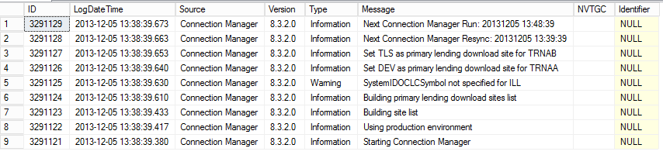

* + The Connection Manager service starts and recognizes that it’s running in a Production Environment (based on Customization key settings).
  + It then identifies any sites (NVTGCs) that exist on the system but lack the proper OCLC settings to connect to OCLC for downloading/updating purposes (again based on Customization key settings).
    - Relevant Customization Keys for this are:
      * OCLCILLAuthorization
      * OCLCILLPassword
      * SystemIDOCLCSymbol
    - In the above example, the “ILL” site is not in use, and therefore its Customization keys are not set up to connect to OCLC.
  + Builds Primary Lending Downloads Sites List
    - **For “Single Server” systems** (including those with multiple delivery locations), only one Primary Lending Download Site will **EVER** exist (as there will only be one OCLC symbol specified in the Customization table).
    - **For “Shared Server” (Multi-site) systems**, each site (NVTGC) with a unique OCLC symbol will automatically be set as a Primary Lending Download Site for that NVTGC.
    - **For “Shared Server” (Multi-site) systems in which an OCLC symbol is SHARED by more than one NVTGC**, ONE (and only one) of the sites sharing that OCLC symbol needs to be designated as the Primary Lending Download site. This is done by adding a key to the Customization table for ONLY that primary download site.

|  |  |  |  |  |  |  |
| --- | --- | --- | --- | --- | --- | --- |
| CustKey | Value | NVTGC | Description | AdminCat | AdminKey | AdminType |
| OCLCPrimaryLendingDownload | Yes | DEV | Is this site the primary site for downloading OCLC requests for that symbol? | System | OCLC | YesNo |

* + - **For “Shared Server” (Multi-site) systems in which MORE than one OCLC symbol is SHARED by more than one NVTGC**, one NVTGC per shared OCLC symbol can be designated as a Primary Lending Download site.
      * For example, if NVTGCs “XYZ”, “PDQ”, and “XXL” all share the OCLC symbol “TRNAA”, and NVTGCs “ABC” and “DEF” both share the OCLC symbol “TRNAB”, “XYZ” and “ABC” could BOTH be set as primary download sites.
  + Schedules the next resync and standard run times for OCLC updating/downloading.

# Debug Logging:

* In those cases where standard Connection Manager logging doesn’t give you enough information about what information is going back and forth between ILLiad and OCLC, it’s possible to set the Connection Manager to use Debug logging.
  + Debug logging is more verbose than standard logging, and covers many additional actions performed by the Connection Manager’s interaction with OCLC that would not normally be logged under standard logging conditions.
* To set up Debug Logging for the Connection Manager:
  + Create a C:\DEBUG folder on the server. **This MUST be done on the C drive**.
  + Inside the C:\DEBUG folder, create a file named “debugon” that does not have any extension.
    - Note: If file extensions are not visible on the server in question, you may need to make them so in order to verify that the file has not been created as “debugon.txt”.
  + Restart the Connection Manager service using the Server Manager.
  + The existence of this C:\DEBUG\debugon folder and file will start the file logging of each request sent and received from Connection Manager as a large number of individual .xml files that get created in that same C:\DEBUG\ folder.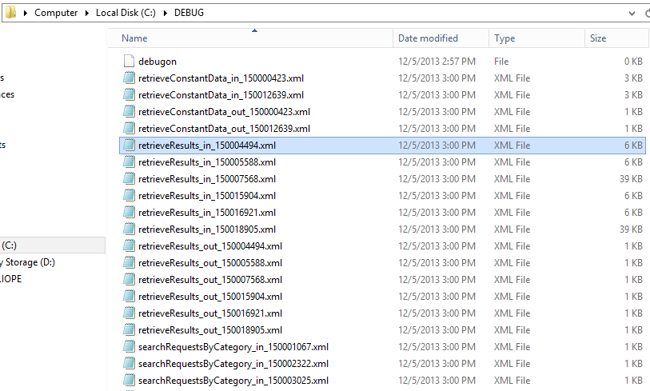
    - These .xml files in turn can then be examined for specifics related to OCLC Communication:

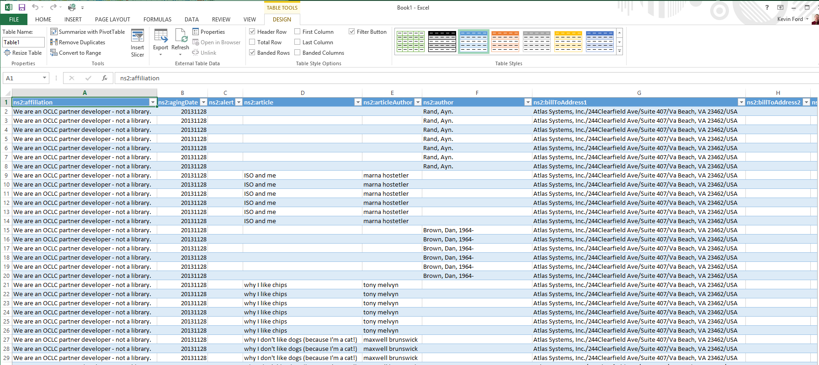

* + Note: **This is NOT a rolling log.** Running the Connection Manager in DEBUG mode can generate a large number of files very quickly, so the DEBUG folder and any files contained within should be deleted when they are no longer necessary for troubleshooting the problem in question.

# Common Connection Manager Messages Often Mistaken for Errors:

* **Warning Empty Constant Data Name specified ADMIN NULL**
  + This is not a problem.
    - It’s just an informational message letting you know that no CD record is specified in the Customization Key (either OCLCILLArticleCD or OCLCILLLoanCD, depending on the request type of the transaction) for the Site (NVTGC) in question.
      * This message is always followed by another indicating that the DEFAULT CD record is being used instead.

# Common Connection Manager Errors:

## Connection Manager Version-Related Errors:

* ILLiad Connection Manager service won’t start. Upon startup, the service throws an error: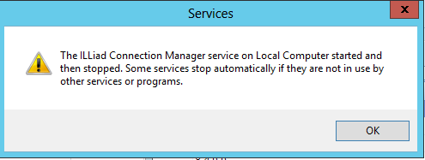
* The related log entry though looks like this:

**This version of the ILLiad Connection Manager (9.0.0.0 does not match the current ILLiad Server configuration 9.1.0.0.**

* Solution: Check the VersionConnectionManager key value in the Customization Manager and verify it against the version of the .exe file itself (located in X:\illiad\Connection Manager\ConnectionManager.exe)
  + Adjust the key setting in the Customization Manager as needed.

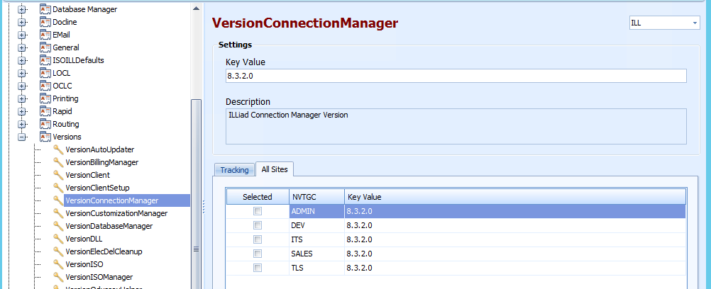

* + Note: Don’t forget that “Shared Server” (multi-site) ILLiad systems will have multiple keys for this, one for each site on the system. They should ALL be set to the same value, and that value should always match the actual version on the CustomizationManager.exe being referenced by the service.

## Informational Errors Relayed from OCLC:

These are just usually the standard “You Can’t Do That” or “Alert” type messages that OCLC generates and relays back to ILLiad when you try to update something that’s not at the correct OCLC status, or when something has been shipped by the wrong library (according to the OCLC record).

* Borrowing:
  + Alert
  + Received not allowed here
  + Record Not Found
  + Return not allowed here
* Lending
  + Alert
  + Complete not allowed here
  + Record Not Found
  + Renewal OK not allowed here

Dealing with OCLC Informational errors:

* Respond to these according to standard OCLC practices and recommended responses (if applicable).
* Once the OCLC records are dealt with (if possible), clear the errors in the ILLiad Client to remove the “Alert” messages.

## Communication Errors involving the OCLC Connection:

These errors are typically caused by communication interruptions of one type or another during ILLiad’s attempt to update the applicable OCLC records.

If the communication issue is transitory and the updates in question are still pending (in the ILLiad ESPUpdates table), they should be updated the next time the Connection Manager runs. If needed quickly, restarting the service should trigger the next Connection Manager run.

* Examples:
  + Connection Manager Error: 210: DOM tree unavailable (set BuildDOM to true and reparse).
  + Update Error

# OCLC Requests Not Downloading (No Errors):

At present, there are two known possible causes for this (although one of them seems to be just a more specifically targeted version of the other):

* Something wrong with the OCLC record that, for whatever reason, impedes the Connection Manager download process.
  + This is usually some strange character or a space-holder non-character of some sort that exists somewhere in the OCLC Request record.
  + If the record in question can be identified, removing the problem request from OCLC manually usually clears out the “log jam” and the rest of the backed-up requests can then download without problems.
  + In some rare instances, this sort of problem will also stop the ILLiad Connection Manager service itself. If that happens and the recovery settings on the service are not sufficient to restart it, it just needs to be manually restarted after fixing the initial problem.
* An incorrectly filled out Constant Data record, specifically the Electronic Delivery and Electronic Delivery Service specifications, either both not being filled out, or having conflicting information in them, creates a conflict in the request itself that impedes the ILLiad Connection Manager request download process.
  + This is a known issue on the OCLC side of the process.
  + You need to fix the CD values and something in the requests themselves to make the process work properly.