How to Encode a Fragment for use with EZproxy

A # that appears in the URL is called a fragment.

When a fragment is involved in a URL being proxied by EZproxy, the URL must be encoded to allow the information to survive through the login process.

To do this, you can visit /encodeurl on any EZproxy server, such as:

https://example.oclc.org/encodeurl

The following will appear

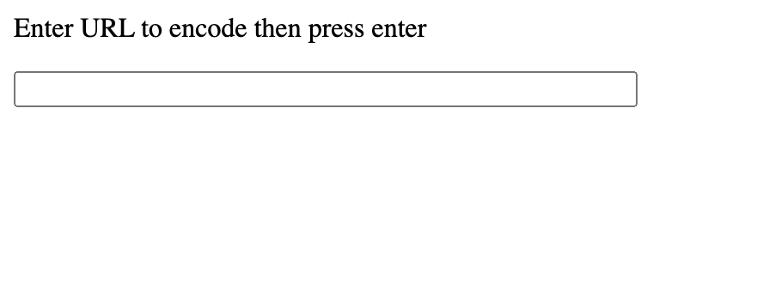

Once you are at that page, paste in the URL you are trying to proxy into the text field. Then hit enter. Here is an example of a fragmented url.

https://www.ministrymatters.com/reader/9781426735707/#sermon.html!page414

the URL will be encoded to:
https%3a%2f%2fwww.ministrymatters.com%2freader%2f9781426735707%2f%23sermon.html%21page414

You can now use that to build the starting point URL, except instead of url=, you use qurl= like this:

https://exampleoclc.org/login?qurl=http%3a%2f%2fwww.ministrymatters.com%2freader%2f9781426735707%2f%23sermon.html%21page414

